Office use only

Thank you for taking part in the MobQoL Project!

Instructions
Please complete all sections of this questionnaire and return via email to n.bray@bangor.ac.uk. Please put an X in all boxes that apply to you, and use the text boxes provided to write your answers where required.

If you need help to read or write please ask a family member or friend to help you, or you could contact the MobQoL project team using the contact details below. If someone does help you to answer this questionnaire please make sure that all of your answers are your own, so please avoid discussing your answers until after you have completed the questionnaire. There are no right or wrong answers! If there are any questions that you do not want to answer please leave them blank.

If you have any further questions please contact the MobQoL Project team-

Address:
Dr Nathan Bray
Ardudwy
Normal Site
Bangor University,
Bangor, Gwynedd
LL57 2PZ
Telephone: 01248 38 2814
Mobile: 07792670053
Email: n.bray@bangor.ac.uk
Website: cheme.bangor.ac.uk

Part 1

Please read the following information and put an X in each box to say ‘yes’
(Please put an X in each box to say ‘yes’)

I have read the information leaflet about the MobQoL Project

I understand what I am being asked to do.

I know that my information and answers in the questionnaire will be kept private.

I know you will not use my name when you report the findings from the project.

I agree to allow the answers I give to be used for educational purposes in the future

I agree to complete the questionnaire as part of the MobQoL Project

Please provide your contact details (these will be kept private and confidential):

Your name

Home address

Post code ________

Phone number ________

Email address ________

In the future if you would like us to write and speak to you in Welsh please tick here:

Part 2: The MobQoL Tool
Office use only

Mobility can mean lots of different things. For some people mobility is about walking around, for other people mobility is about using a wheelchair or other aids. The aim of the MobQoL Tool is to find out how your mobility affects your quality of life, no matter how you move around or what mobility aids you use.

For each question, please type X in ONE box to show which statement best describes your quality of life and mobility at the moment. If you use any mobility aids, think about how they help or hinder you in relation to each question
2
1. Accessibility at home

I do not find it difficult to move around my home
I find it a little bit difficult to move around my home
I find it very difficult to move around my home
I cannot move around my home
2. Accessibility in the wider community (such as public spaces, shops or other homes/properties)

I never find it difficult to access other buildings and places outside my home
I sometimes find it difficult to access other buildings and places outside my home
I often find it difficult to access other buildings and places outside my home
I always find it difficult to access other buildings and places outside my home
3. Safety (such as steadiness, balance, risk of injury or personal safety)

Moving around in my everyday life never makes me feel unsafe
Moving around in my everyday life sometimes makes me feel unsafe
Moving around in my everyday life often makes me feel unsafe
Moving around in my everyday life always makes me feel unsafe
4. Relationships (such as friendship, love or companionship

My mobility never has a negative impact on my relationships with family, friends and loved ones
My mobility sometimes has a negative impact on my relationships with family, friends and loved ones
My mobility often has a negative impact on my relationships with family, friends and loved ones
My mobility always has a negative impact on my relationships with family, friends and loved ones
5. Social inclusion (such as experiences of prejudice or discrimination)

I never feel that people treat me badly because of my mobility
I sometimes feel that people treat me badly because of my mobility
I often feel that people treat me badly because of my mobility
I always feel that people treat me badly because of my mobility
6. Contribution (such as contributing at home, work, education or in the community)

My mobility never makes it difficult to contribute and do the things that make me feel valued
My mobility sometimes makes it difficult to contribute and do the things that make me feel valued
My mobility often makes it difficult to contribute and do the things that make me feel valued
My mobility always makes it difficult to contribute and do the things that make me feel valued
7. Activities (such as taking part in hobbies, sports or socialising)

My mobility never makes it difficult to take part in the activities that are important to me
My mobility sometimes makes it difficult to take part in the activities that are important to me
My mobility often makes it difficult to take part in the activities that are important to me
My mobility always makes it difficult to take part in the activities that are important to me
8. Personal care (such as looking after yourself, washing, dressing or using the toilet)

I am very satisfied with my personal care arrangements
I am satisfied with my personal care arrangements
I am unsatisfied with my personal care arrangements
I am very unsatisfied with my personal care arrangements
9. Pain and discomfort

Moving around in my everyday life is not painful or uncomfortable
Moving around in my everyday life is a little bit painful or uncomfortable
Moving around in my everyday life is very painful or uncomfortable
Moving around in my everyday life is extremely painful or uncomfortable
10. Independence

I am always satisfied with my level of independence
I am often satisfied with my level of independence
I am sometimes satisfied with my level of independence
I am never satisfied with my level of independence
11. Energy (including physical and mental energy)

Moving around in my everyday life rarely makes me feel exhausted
Moving around in my everyday life sometimes makes me feel exhausted
Moving around in my everyday life often makes me feel exhausted
Moving around in my everyday life always makes me feel exhausted
12. Self-esteem (including identity, confidence and self-consciousness)
3

I never feel bad about myself because of my mobility
I sometimes feel bad about myself because of my mobility
I often feel bad about myself because of my mobility
I always feel bad about myself because of my mobility
13. Mood and emotions

I never feel low, sad or unhappy because of my mobility
I sometimes feel low, sad or unhappy because of my mobility
I often feel low, sad or unhappy because of my mobility
I always feel low, sad or unhappy because of my mobility
14. Frustration (such as feelings of anger or resentment)

My mobility does not make me feel frustrated
My mobility makes me feel a little bit frustrated
My mobility makes me feel very frustrated
My mobility makes me feel extremely frustrated
15. Anxiety (such as feelings of worry or stress)

My mobility does not make me feel anxious
My mobility makes me feel a little bit anxious
My mobility makes me feel very anxious
My mobility makes me feel extremely anxious

Please continue to the next page

Part 3: Questions about your health

Under each heading, please type X in the ONE box that best describes your health TODAY.

MOBILITY
I have no problems in walking about
I have slight problems in walking about
I have moderate problems in walking about
I have severe problems in walking about
I am unable to walk about
SELF-CARE
I have no problems washing or dressing myself
I have slight problems washing or dressing myself
I have moderate problems washing or dressing myself
I have severe problems washing or dressing myself
I am unable to wash or dress myself
USUAL ACTIVITIES (e.g. work, study, housework, family or leisure activities)
I have no problems doing my usual activities
I have slight problems doing my usual activities
I have moderate problems doing my usual activities
I have severe problems doing my usual activities
I am unable to do my usual activities
PAIN / DISCOMFORT
I have no pain or discomfort
I have slight pain or discomfort
I have moderate pain or discomfort
I have severe pain or discomfort
I have extreme pain or discomfort
ANXIETY / DEPRESSION
I am not anxious or depressed
I am slightly anxious or depressed
I am moderately anxious or depressed
I am severely anxious or depressed
I am extremely anxious or depressed

Part 4: Questions about your quality of life

Please indicate which statements best describe your overall quality of life at the moment by typing X in ONE box for each of the five groups below.

1. Feeling settled and secure

I am able to feel settled and secure in all areas of my life

I am able to feel settled and secure in many areas of my life

I am able to feel settled and secure in a few areas of my life

I am unable to feel settled and secure in any areas of my life

2. Love, friendship and support

I can have a lot of love, friendship and support

I can have quite a lot of love, friendship and support

I can have a little love, friendship and support

I cannot have any love, friendship and support

3. Being independent

I am able to be completely independent

I am able to be independent in many things

I am able to be independent in a few things

I am unable to be at all independent

4. Achievement and progress

I can achieve and progress in all aspects of my life

I can achieve and progress in many aspects of my life

I can achieve and progress in a few aspects of my life

I cannot achieve and progress in any aspects of my life

5. Enjoyment and pleasure

I can have a lot of enjoyment and pleasure

I can have quite a lot of enjoyment and pleasure

I can have a little enjoyment and pleasure

I cannot have any enjoyment and pleasure

Part 5: Questions about how your mobility aids affect you

On the next page are 26 words and phrases which describe how using a mobility aid, such as a wheelchair, may affect a user. For each word or phrase, type X in the appropriate box to show how you are personally affected by your mobility aids. If you use multiple mobility aids please focus on the piece of equipment you use the most. You can score each item from -3 (large negative impact) to 3 (large positive impact). Some of the words and phrases might seem unusual but it is important that you try to answer all of the 26 items.
As an example, let’s look at how you might rate how your mobility aid affects your level of “happiness”:
- If you feel very much more happy than before getting your mobility aid: put a mark in the “3” box
- If you feel somewhat more happy, but not as much as you expected: put a mark in the “1” or “2” box
- If you do not feel any more or less happy: put a mark in the “0” box.
- If you feel somewhat unhappy (or less happy than you used to feel): put a mark in the “-1” or “-2” box
- If you feel quite unhappy (or a lot less happy than you used to feel): put a mark in the “-3” box

Please continue to the next page

For each question, please type X in ONE box to show how your mobility aids affect you

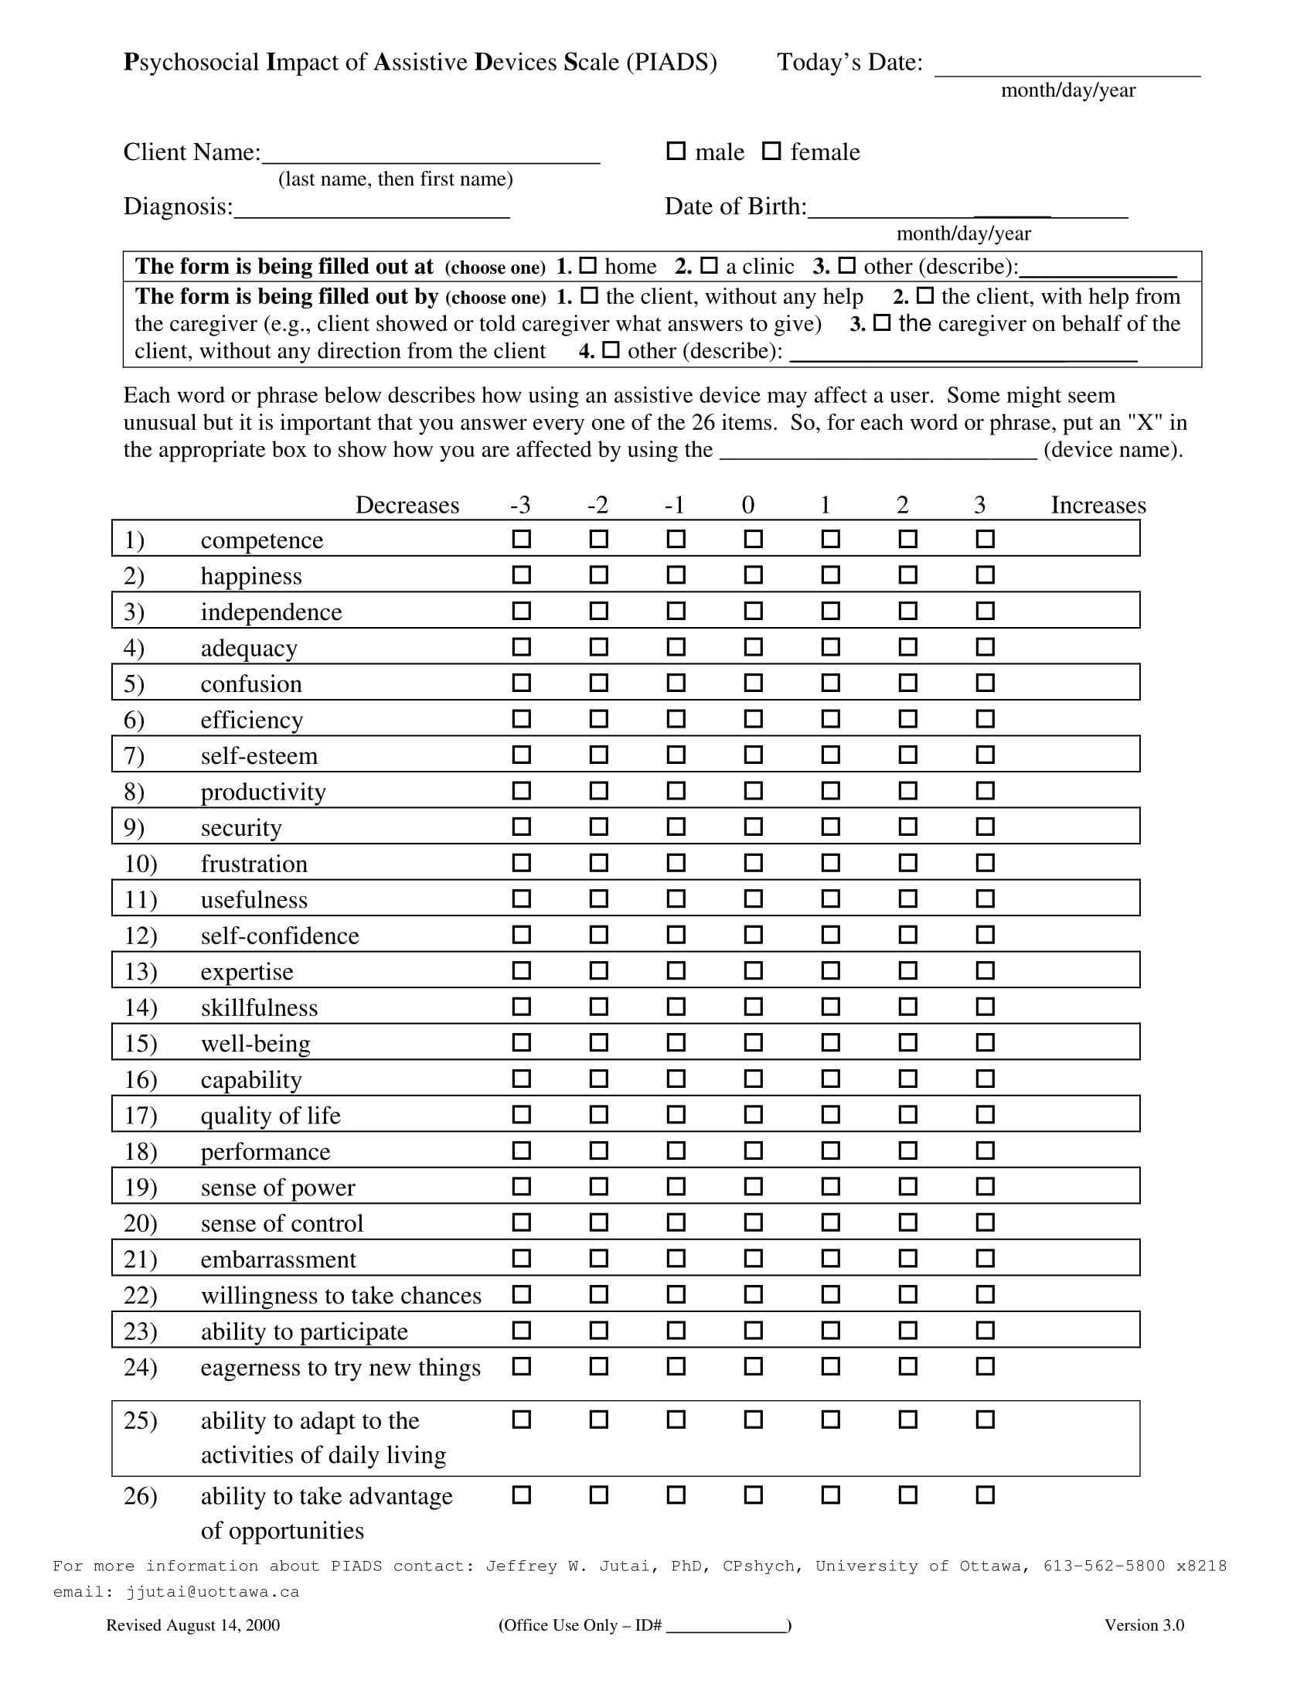

Part 6: Questions about you
Please type X in each box that applies to you and write any answers in the text boxes provided, where required. If you do not know the answer to a question please leave it blank.

Q1 Your gender? Male Female Other

Q2 How old are you? Years

Q3 What is your current employment status?

Full-time Part-time

Unemployed Student

Parent/carer Sick leave

Retired

Q4 Overall, do you consider your health to be stable at the moment? Yes No

Q5 If you have been diagnosed with a disability/condition which affects your ability to move around, please provide details here:

Q6 Please provide details of any mobility aids you currently use:
 |  | Brief description of mobility aid  (e.g. powered or manual wheelchair) Please state full product name if known |  |  |  | What do you use this mobility aid for?  (e.g. everything, home, work, exercise/sport, leisure activities)
Mobility aid 1
(main one you use)
Mobility aid 2
Mobility aid 3
Mobility aid 4

Q7 How long have you been using mobility aids? Years

Q8 How often do you use your mobility aid(s)? (Please choose only one option)

A little of the time Some of the time

Most of the time All of the time

Thank you for completing this questionnaire

Please return your completed questionnaire via email to n.bray@bangor.ac.uk, we will send you a £5 voucher as a thank you for completing this questionnaire!

